Error

Character, decimal, and binary parameters cannot have a precision of zero. Error in parameter xxx

Solution Link

https://knowledge.informatica.com/s/article/113897?language=en\_US

My Solution

If any field data type of Source/Target table is binary then in informatica, when we inmport that field,

it's data type stay same as like Source/Target table but precision is seted default zero (0). So the above

error is shown. So, make sure that field precision is as much longer like 99999999999999999 in Informatica

imported source/target.

Error

What are the Informatica Domain and Service timeout parameters?

Solution Link

https://knowledge.informatica.com/s/article/19191?language=en\_US#:~:text=The%20limit%20on%20resilience%20timeout,default%20value%20is%20180%20seconds.

My Solution

See the serial no "10. Resilence Solution" where change the time out as per need.

Error

Need SYSDATE – 1 in expression transformation for effective tracking

Solution Link

https://community.spiceworks.com/topic/2412548-need-sysdate-1-in-expression-transformation-for-effective-tracking

https://network.informatica.com/onlinehelp/s/question/0D56S0000AD6TciSQF/how-to-convert-sysdatetime-to-sysdate

My Solution

TO\_CHAR(ADD\_TO\_DATE(SYSDATE,'DD',-1),'YYYYMMDD')

Error

# "Model Repository Service used to store historical data is not configured. Please contact administrator" in the Administrator Console while previewing the last hour trend of the CPU usage.

Solution link

<https://knowledge.informatica.com/s/article/535252?language=en_US#:~:text=Perform%20the%20following%20steps%20to,to%20be%20an%20Administrator%20user.>

My Solution

To resolve the issue, configure a new MRS in the Informatica Administrator console for monitoring.

**Note**  
We strongly recommend creating a new MRS for the monitoring purpose as this store historical data of the domain/job execution and needs to be isolated for the design MRS

Perform the following steps to resolve the issue:

* Create a new MRS in the Domain.
* Go to *Informatica Administrator console>Manage Tab>Domain>Services and Nodes>click Monitoring configuration>Assign MRS configured*
* The Username to be provided in the monitoring configuration is recommended to be an Administrator user. If a non-admin user is configured for monitoring, the monitoring MRS may not be able to fetch some stats.
* Configure the number of days to store the historical summary and detailed data. The recommendation is to configure this value to less than or equal to 4 days. Any historical data older than 4 days will be purged from monitoring MRS.
* After configuring the above properties, save the changes and restart all Data Integration Services in the domain to apply the settings.
* Click on Display current statistics. Now, you can view the last hour trend.

Error

# "FATAL: ESCMN\_10002 Unable to connect to the Model Repository Service." while trying to enable email notification in the Email service

Solution Link

[ERROR: "FATAL: ESCMN\_10002 Unable to connect to the Model Repository Service." while trying to enable email notification in the Email service (informatica.com)](https://knowledge.informatica.com/s/article/514364?language=en_US" \l ":~:text=ERROR: "FATAL: ESCMN_10002 Unable to connect to the,following error is reported in the Email service:)

My Solution

Already, I have added MRS (Model Repository Service) but it’s showing above error. I have tried in different ways but finally which process solve or work for this issue that I am not sure. But I guess that when I have added MRS in Email Service, at that time password was wrong.

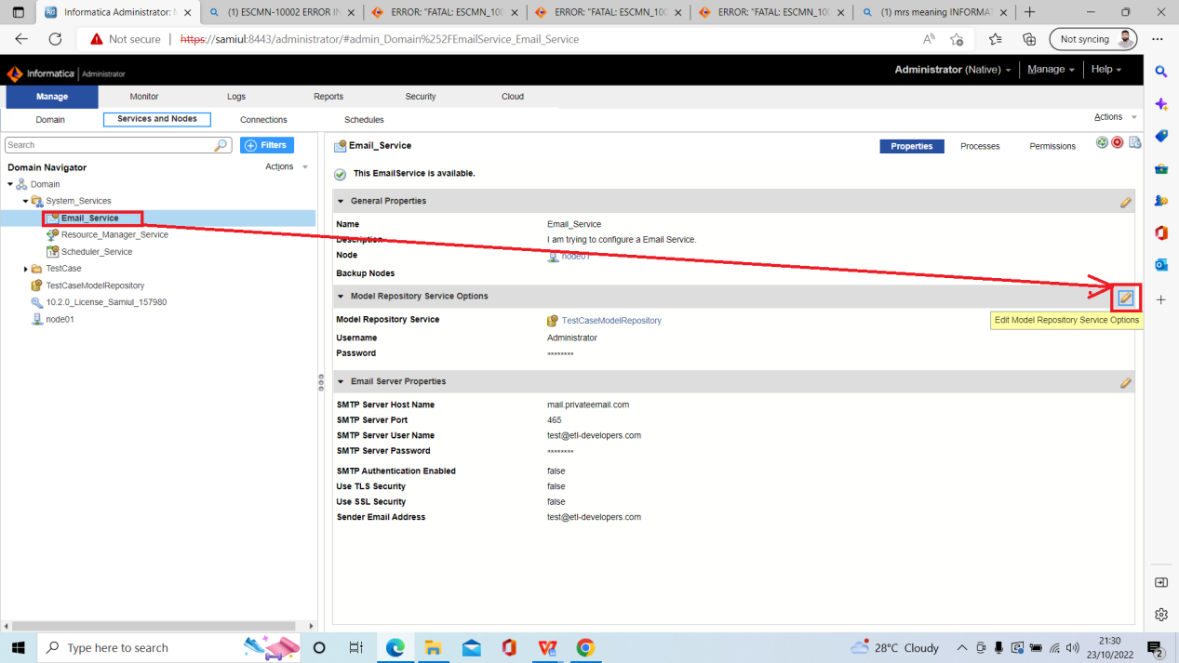

So, when I change password from the above option, then may be it’s start to work.

Username: Administrator

Password: Administrator

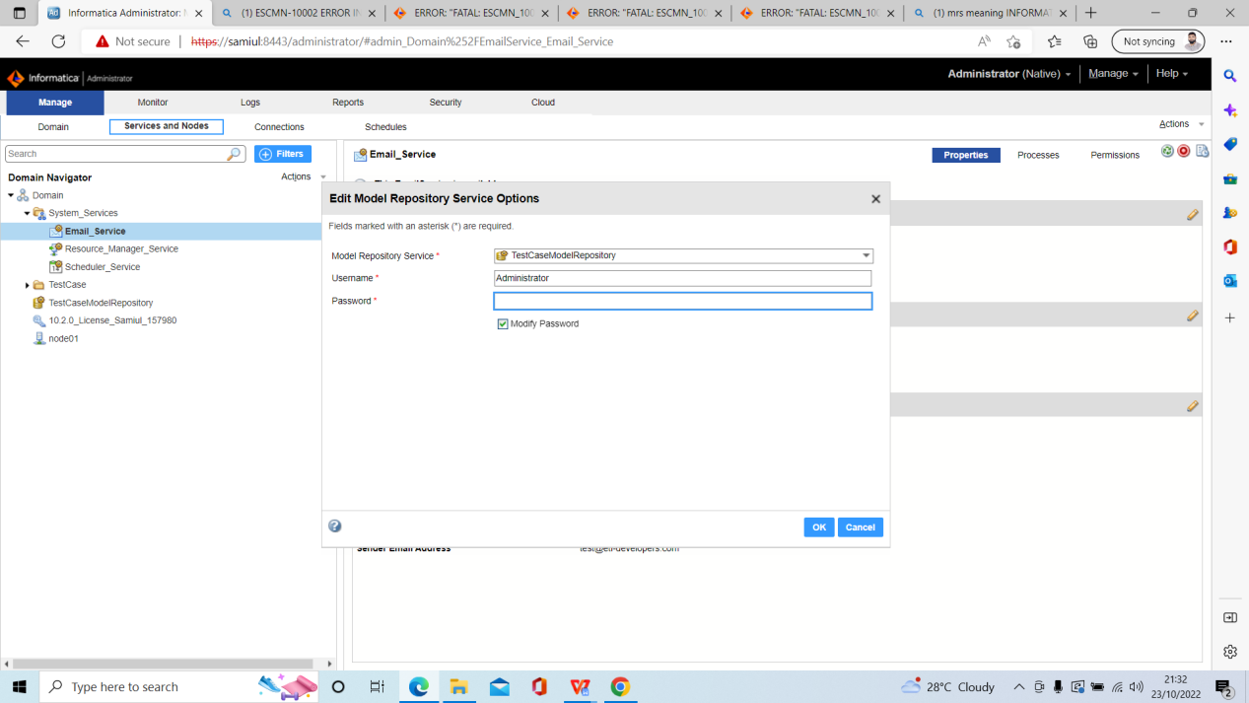

Error

# NTSERV\_10181: Extended MAPI Error. MAPIInitialize failed, return code [-2147467259]

**Solution link**

<https://knowledge.informatica.com/s/article/100690?language=en_US>

My Solution

[24-10-2022]

Till now, the error is not solved.